3D Max template file
!!! on opening the file, you might have this warning, just hit open !!!
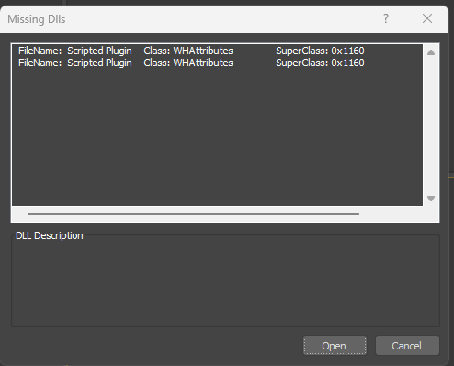
Here is what you are going to find in the scene:
-several object going from very small to the larger one
- their respective material assigned to each one
-also a complete node structure for each one of then
-as well with their LOD and shadow proxies.
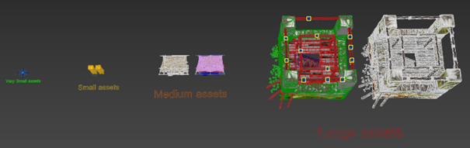
Let’s go over the whole file
In the scene Explorer you would find each asset ready to be exported
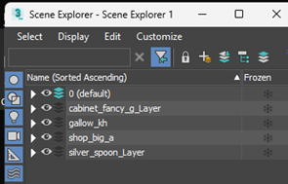 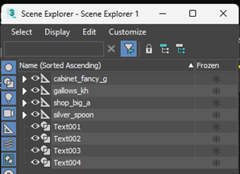
either by layer or by hierarchy
And their respective materials
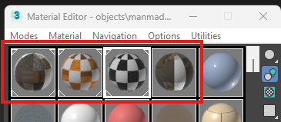
From the smallest:
**silver_spoon
**
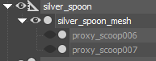
where you can see that the mesh is directly linked to the export node. Because it is a small model, only physical proxy are included and **linked to the mesh itself as there is no need for LOD’s and shadow proxys.
Why no need for shadow proxy and LOD‘s** here it‘s because the material is really simple
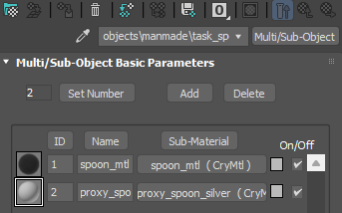
**
To the biggest and complex one:**
gallow_kh
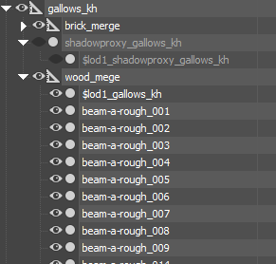
Where the model is compossed from a lot of element which are grouped in the merge nodes (brick_merge and wood_merge) as well with the shadow proxys and the LOD1 also included in a merge node
**!!! we can see here that the shadow proxies work a bit differently!!!
**
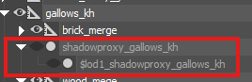
the LOD 0 (main model) shadow proxy is linked directly to the export node gallow_kh and the LOD1 shadow proxy is linked to the first shadow proxy.
!!! the naming convention in the hierachy for the shadow proxy here is really important, same with the LOD’s!!!

